**CRB not interpolated Old Data**

Learning Regression Tree...

Elapsed time is 0.300614 seconds.

Training RMSE(W): 15.45, R2: 0.873, RMSE/peak: 0.0224, NRMSD: 3.29

Learning a cross validated tree...

Elapsed time is 2.599577 seconds.

Cross Validated Training RMSE(W): 23.89, R2: 0.697, RMSE/peak 0.0347, NRMSD: 5.08

Learning a Random Forest...

Elapsed time is 89.411954 seconds.

Random Forests Training RMSE(W): 17.86, R2: 0.831, RMSE/peak 0.0259, NRMSD: 3.80

Testing RMSE(W): 21.14, R2: 0.401, RMSE/peak: 0.0393, NRMSD: 4.56

Cross Validated Testing RMSE(W): 18.69, R2: 0.532, RMSE/peak 0.0348, NRMSD: 4.04

RF (Testing) RMSE(W): 13.62, R2: 0.751, RMSE/peak 0.0253, NRMSD: 2.94

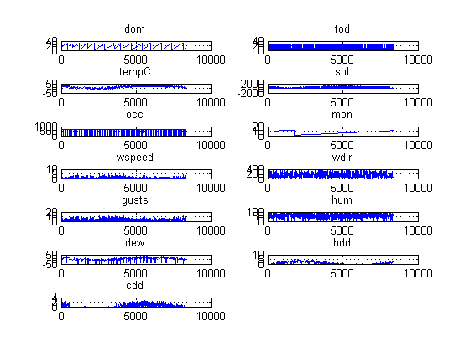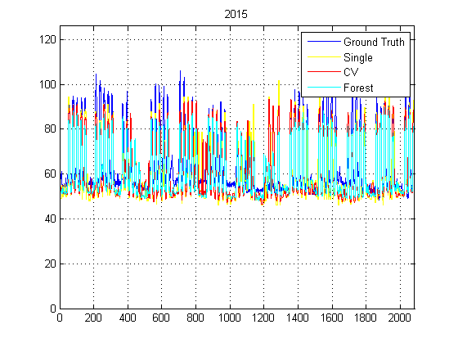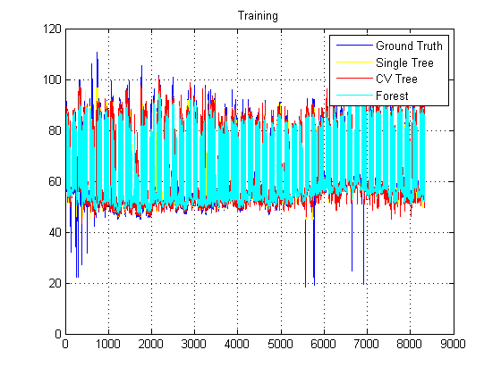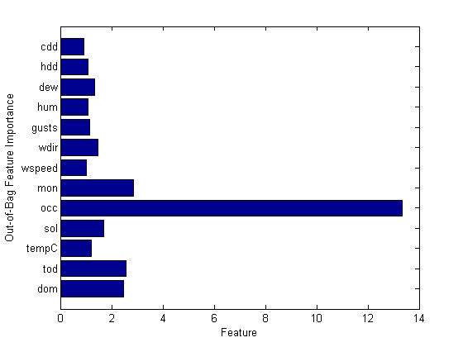

**CRB interpolated Old Data**

Learning Regression Tree...

Elapsed time is 0.298571 seconds.

Training RMSE(W): 17.83, R2: 0.840, RMSE/peak: 0.0259, NRMSD: 3.79

Learning a cross validated tree...

Elapsed time is 2.636431 seconds.

Cross Validated Training RMSE(W): 26.29, R2: 0.653, RMSE/peak 0.0382, NRMSD: 5.59

Learning a Random Forest...

Elapsed time is 90.080737 seconds.

Random Forests Training RMSE(W): 19.23, R2: 0.814, RMSE/peak 0.0279, NRMSD: 4.09

Testing RMSE(W): 23.58, R2: 0.281, RMSE/peak: 0.0439, NRMSD: 5.10

Cross Validated Testing RMSE(W): 20.87, R2: 0.437, RMSE/peak 0.0388, NRMSD: 4.52

RF (Testing) RMSE(W): 15.42, R2: 0.693, RMSE/peak 0.0287, NRMSD: 3.34

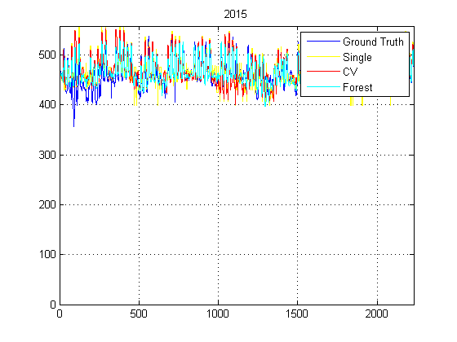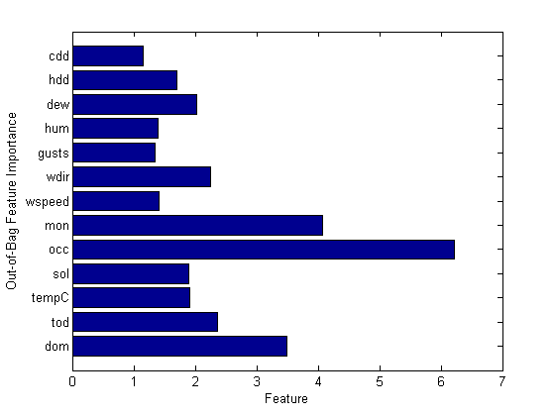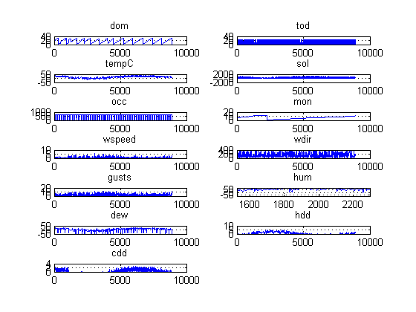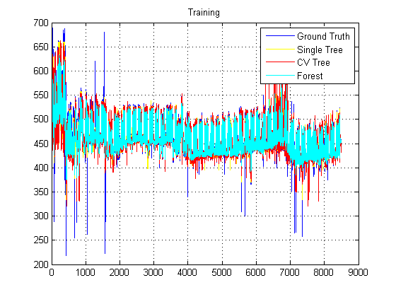

**CRB Interpolated New Data**

Learning Regression Tree...

Elapsed time is 0.400792 seconds.

Training RMSE(W): 33.28, R2: 0.845, RMSE/peak: 0.0242, NRMSD: 3.87

Learning a cross validated tree...

Elapsed time is 3.384436 seconds.

Cross Validated Training RMSE(W): 48.98, R2: 0.664, RMSE/peak 0.0356, NRMSD: 5.69

Learning a Random Forest...

Elapsed time is 110.120420 seconds.

Random Forests Training RMSE(W): 36.00, R2: 0.819, RMSE/peak 0.0262, NRMSD: 4.18

Testing RMSE(W): 36.29, R2: 0.561, RMSE/peak: 0.0332, NRMSD: 3.85

Cross Validated Testing RMSE(W): 31.95, R2: 0.660, RMSE/peak 0.0293, NRMSD: 3.39

RF (Testing) RMSE(W): 26.75, R2: 0.761, RMSE/peak 0.0245, NRMSD: 2.84

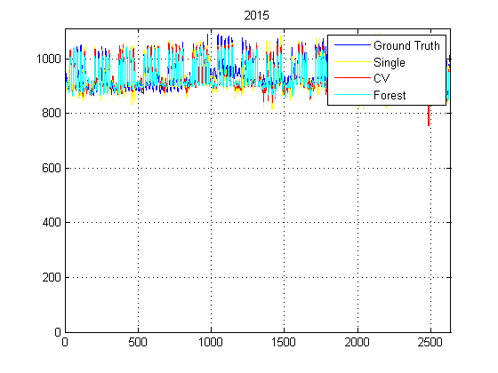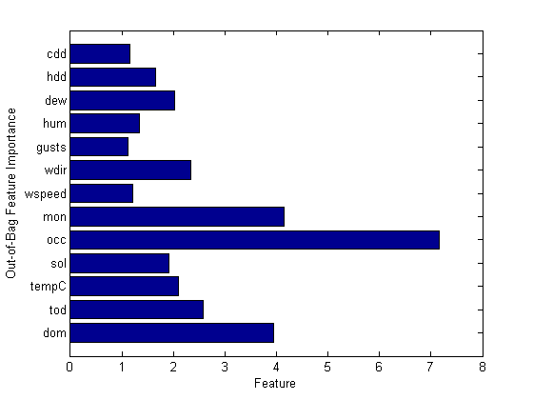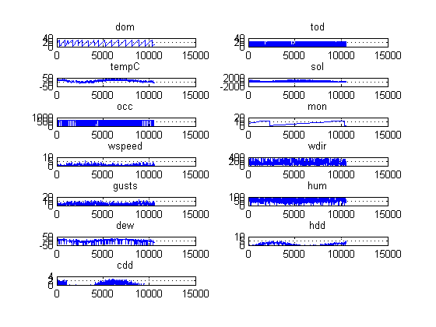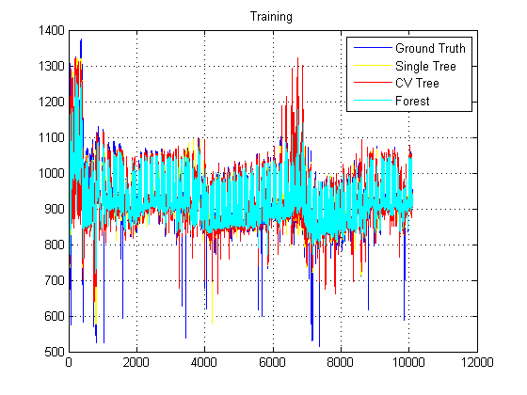

**CRB Not Interpolated New Data**

Learning Regression Tree...

Elapsed time is 0.384977 seconds.

Training RMSE(W): 30.65, R2: 0.861, RMSE/peak: 0.0223, NRMSD: 3.56

Learning a cross validated tree...

Elapsed time is 3.170236 seconds.

Cross Validated Training RMSE(W): 45.03, R2: 0.699, RMSE/peak 0.0327, NRMSD: 5.23

Learning a Random Forest...

Elapsed time is 106.632688 seconds.

Random Forests Training RMSE(W): 32.91, R2: 0.839, RMSE/peak 0.0239, NRMSD: 3.82

Testing RMSE(W): 32.13, R2: 0.655, RMSE/peak: 0.0294, NRMSD: 3.41

Cross Validated Testing RMSE(W): 29.12, R2: 0.717, RMSE/peak 0.0267, NRMSD: 3.09

RF (Testing) RMSE(W): 25.00, R2: 0.791, RMSE/peak 0.0229, NRMSD: 2.65

